In previous days, I found out a github project which is really interesting.
GitHub - peng-zhihui/L-ink_Card: Smart NFC & ink-Display Card
I wanted to follow instructions to make one by myself, but I found out I can be Improved. So in insistent. I found an instruction of how to increase the battery amount and change the buttons in order to get it neat.
Link-Card改进版 - 立创开源硬件平台
So I started working on it, here is a record on what I did.
---------------------------------------------------------------------------------------------------------------------------------
- PCB board
Though I did have the design for the card. How to actually make it became one of my main problem. Fortunately, I found the Bamtam Milling machine in the lab.
First, I transfer the design to a gerber file in order to print out.
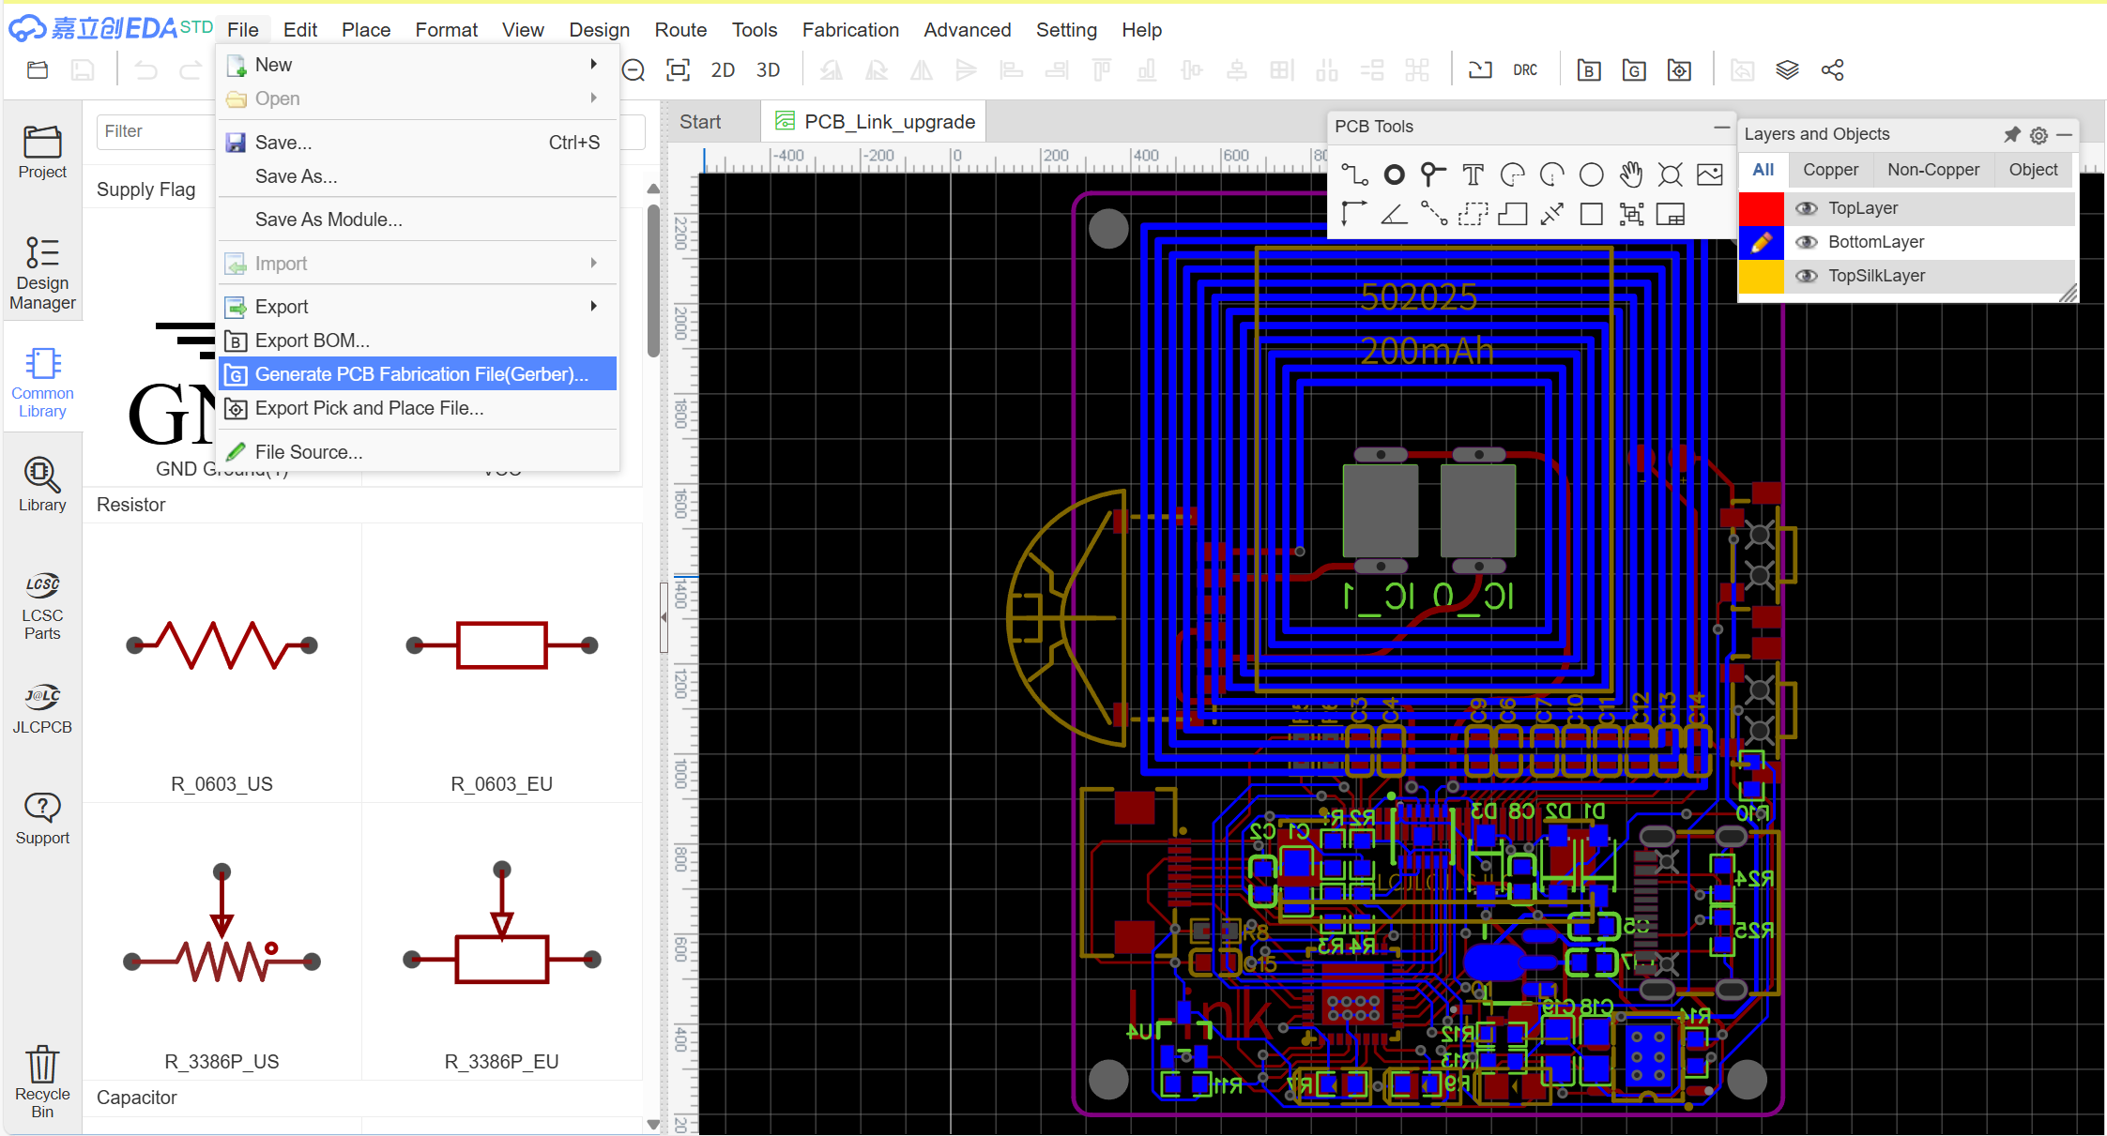
Then, to test the machine, I used a official btm file to test it.
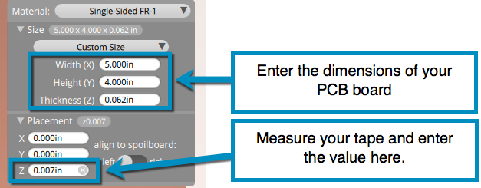
I homed the machine, then entered dimensions(By the way, there should be tape attaching the board to the surface)

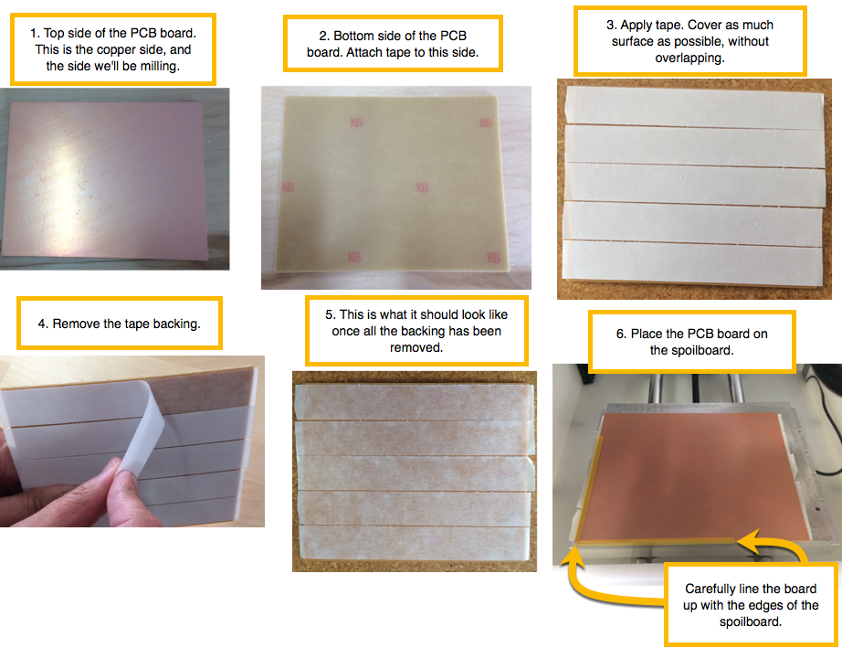
rrary

Then it worked out perfectly. So I put my file in, but I don’t have a double sided board(Which is necessary for my project (QWQ
So I am still waiting for my board(This project is unfinished)
- Materials
I sorted out the materials I need to made this card
Which is in this form.
I bought them from www.SZLCSC.com
Another two material I need the a 0.003 mill and a double sided pcb board prototype. (They did not arrive yet)
- Shell
The shell is pretty easy, I used the 3D model provided by the author(Which is this one)
And I import it into a 3D printer.
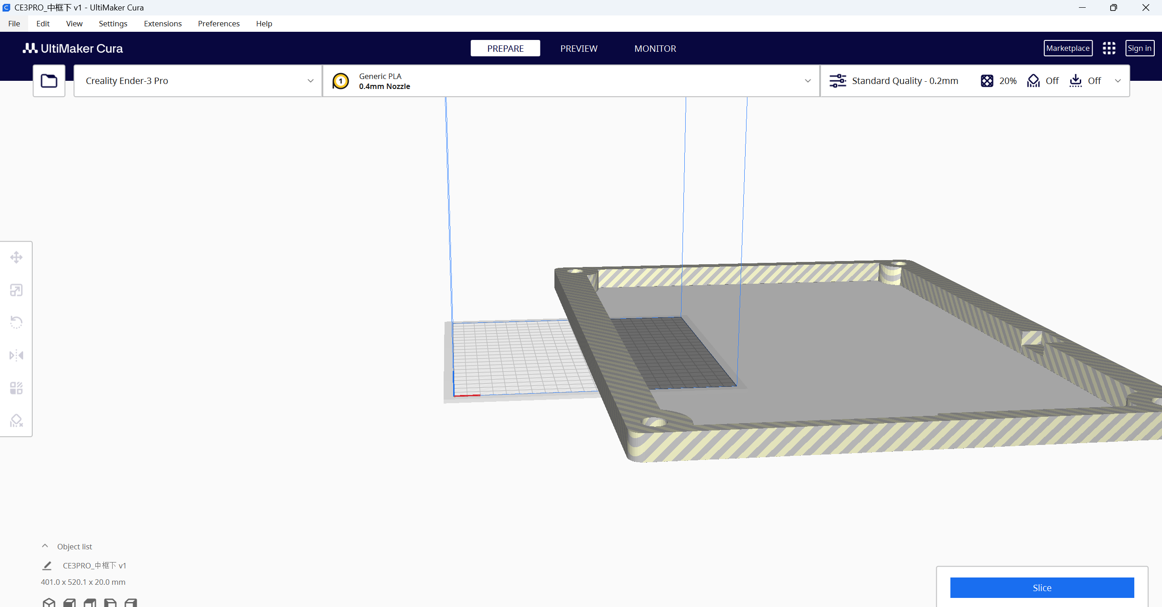

By using UltiMaker Cura, you can easily change an 3D model into Stl files, which can be used by 3D printers. Just importyour 3D model in, after changing its direction, click export.
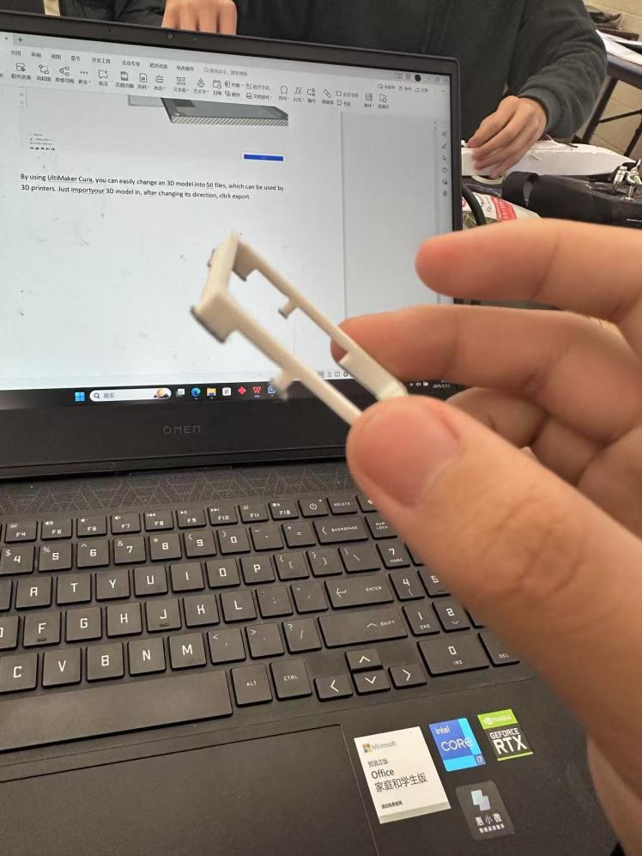
This is what I got

This is what I did so far. I am planing to import the system into the stm32 after I solder the board to the materials. Hope I can finish it successfully.

